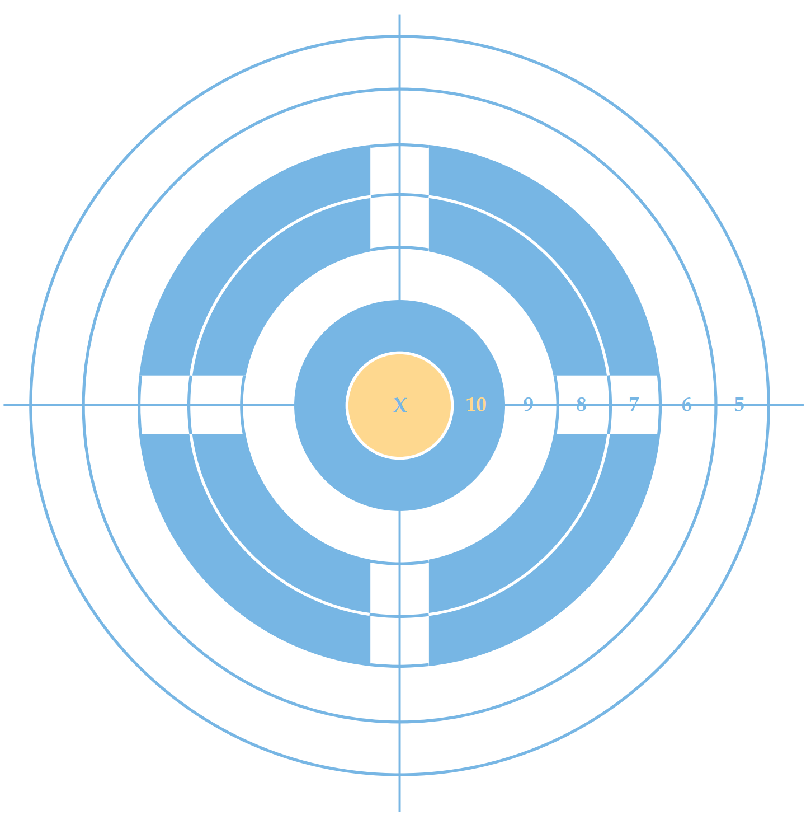

RIMFIRE PISTOL LEAGUE TARGET TWO (2) Full Name: _____________________________
Pistol @ 7 yards Limited / 15 yards Optic Date: _____________
Signature: _______________________________
Week Match #: _______

